**Stacks**

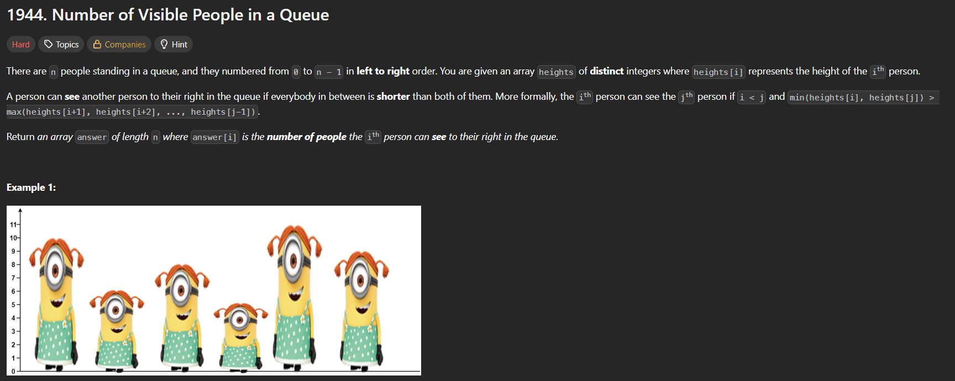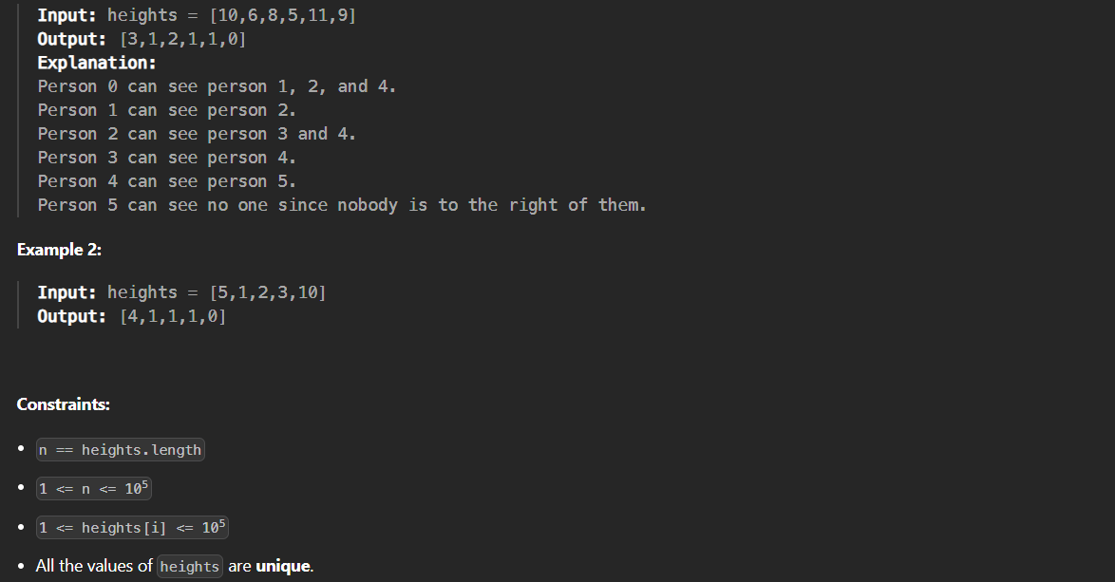

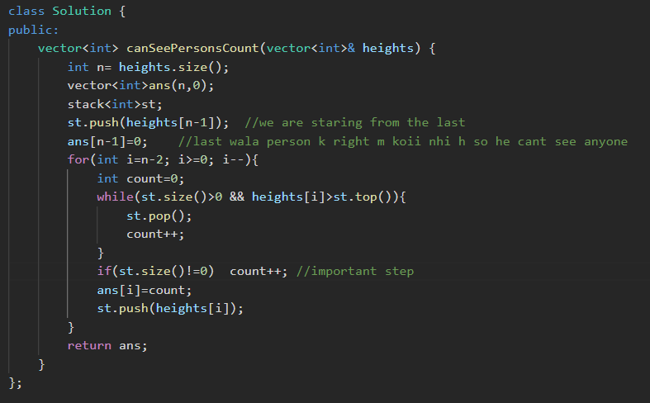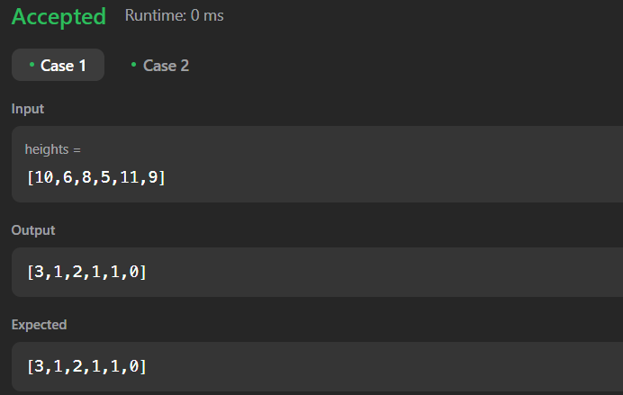

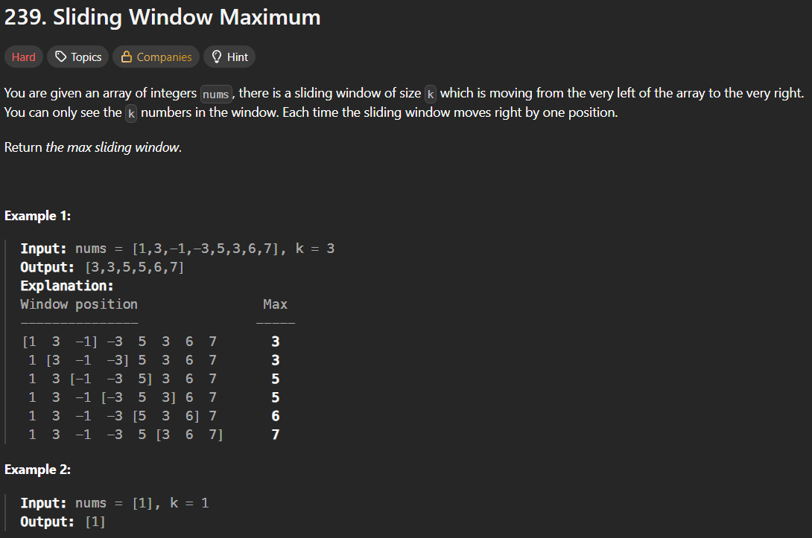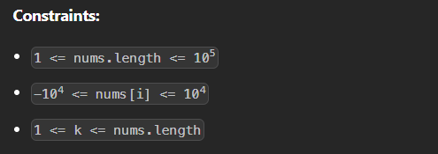



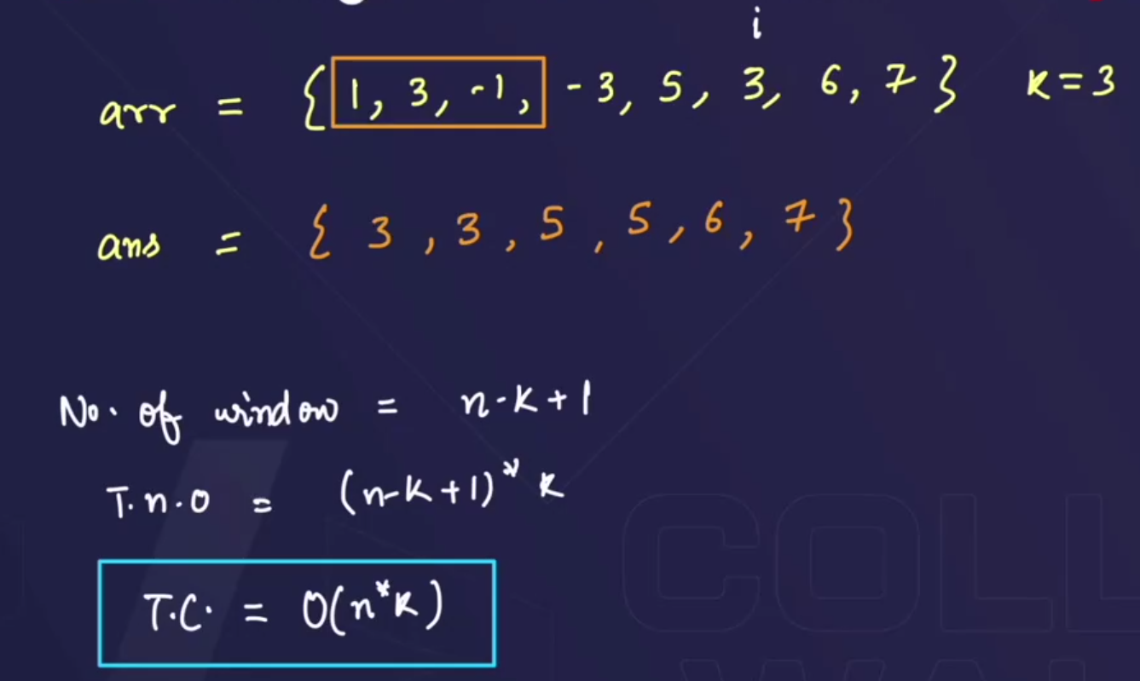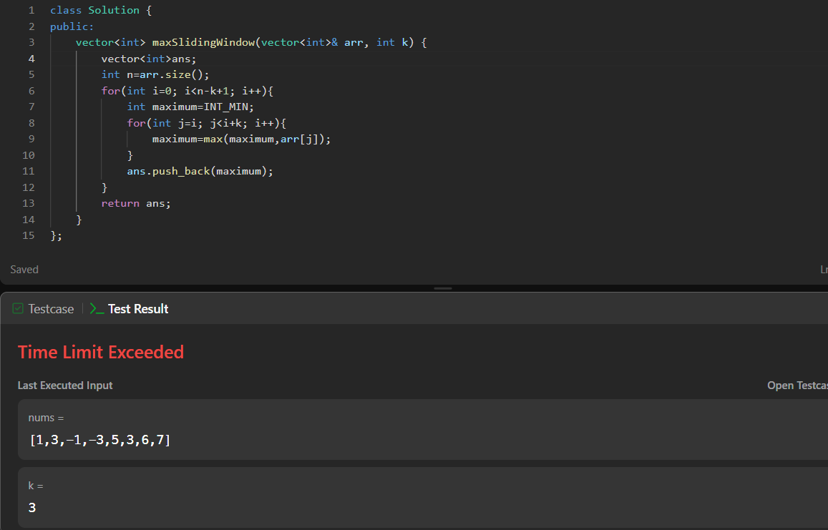



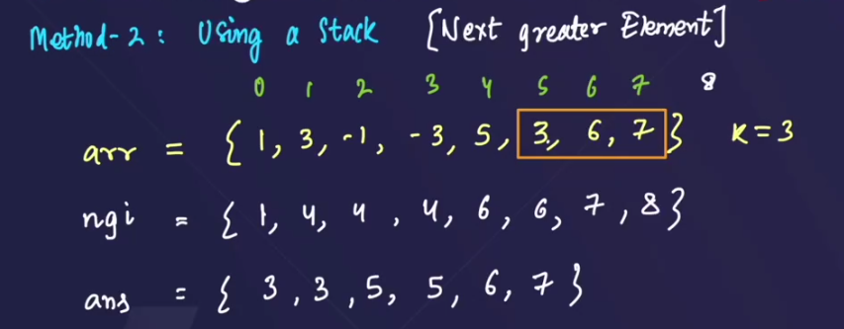



* Stores the index of next greater element.
* Answer will be calculated by : put “i” variable on 1st element of “ngi” array, then check the nextGreater element of each element , if it lies inside the window then push it into the answer array and if it does not lie inside the window it means that ki that element is the largest element in the window.



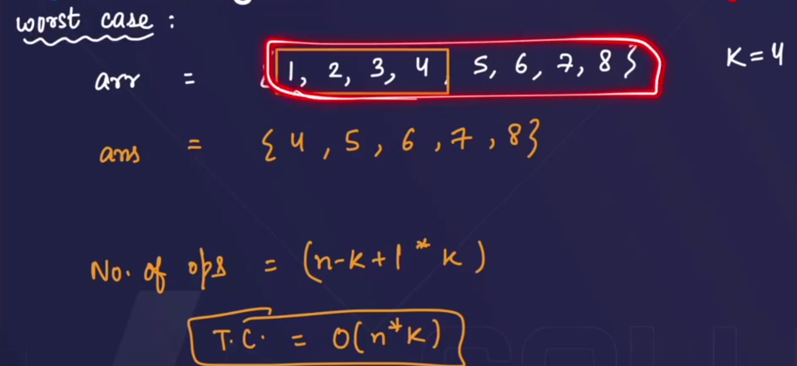

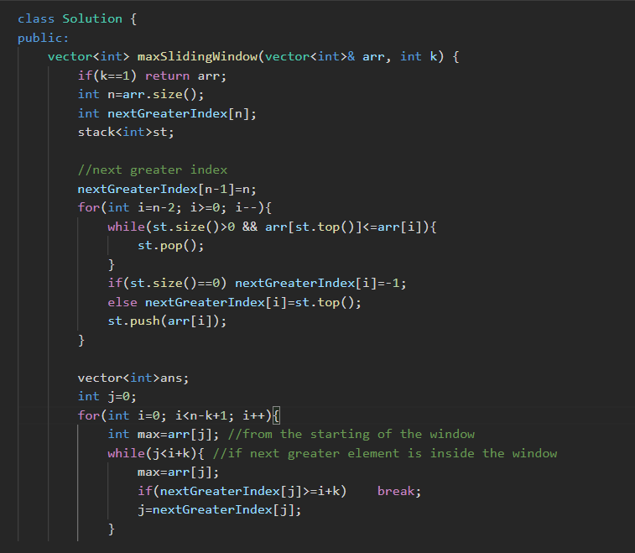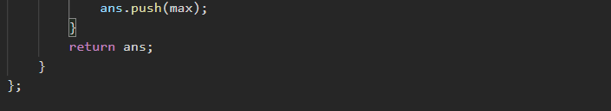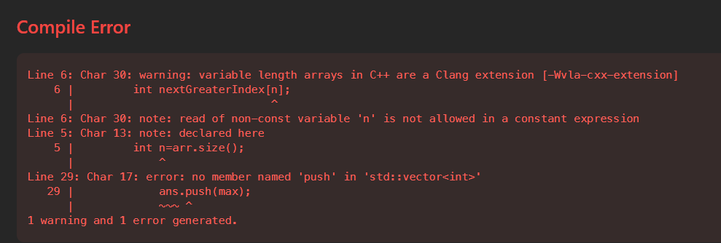



* Raghav sir solved with the same technique , and submitted the answer , but when I am writing the same code , it is giving the error.

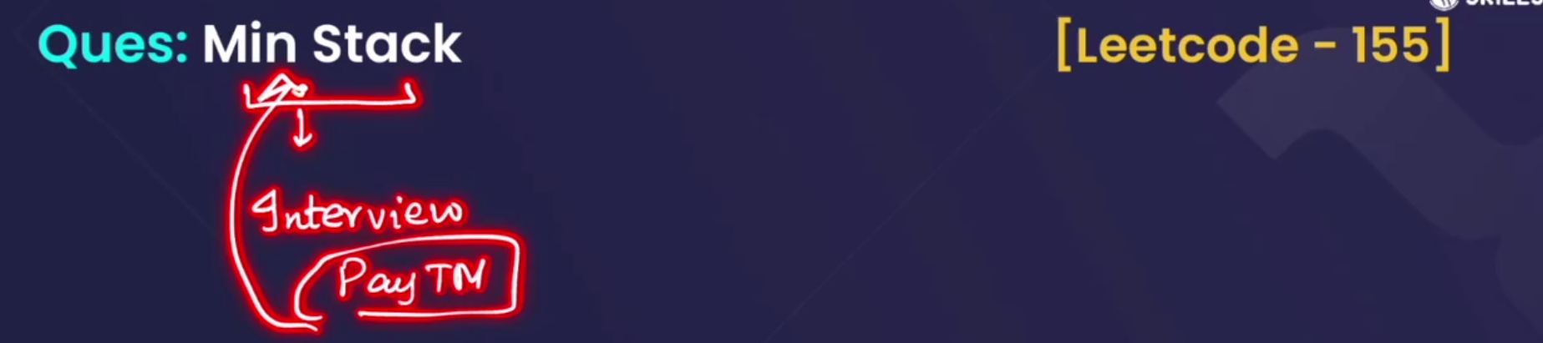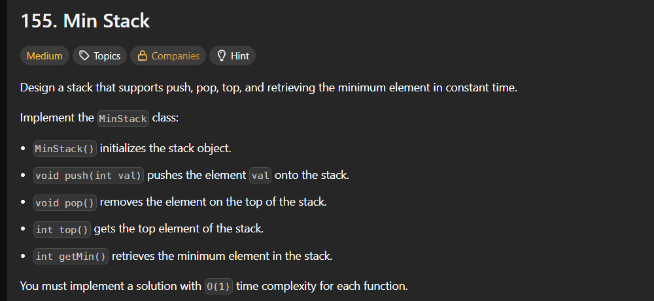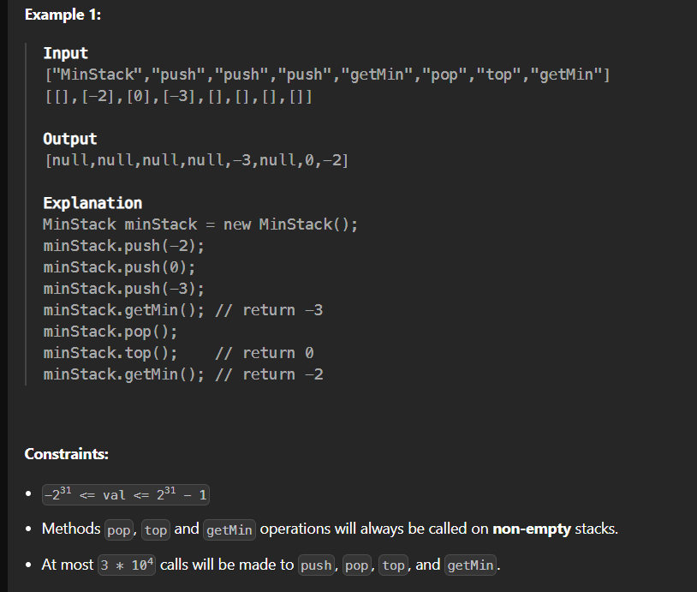

* In this Question , we have to implement all the stack operations(push,pop,top()),get on our own.
* 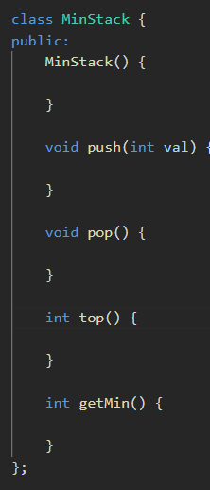🡪 this was given



* 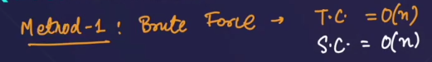



* Solution: starting ka 3 function easy h, but to make the **getMin()** function in a stack, we cant directly get the min value of a stack.

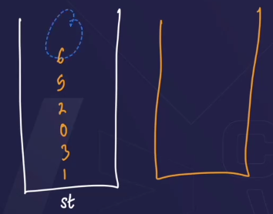🡪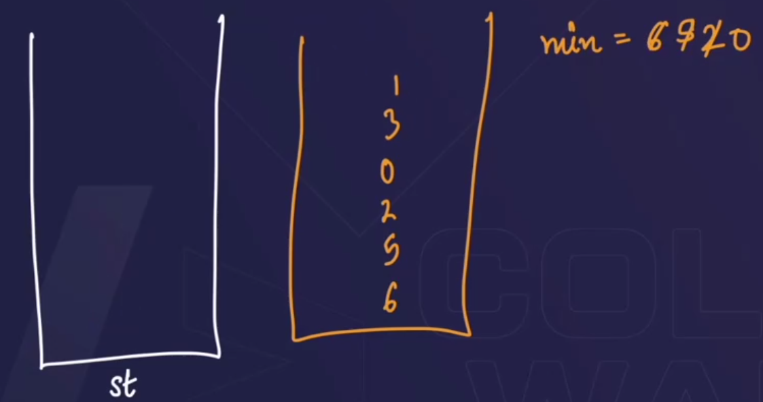🡪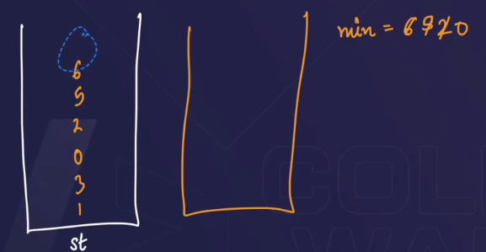

1st we need to make a variable and stack ko empty krenge and jo value chota hoga usko variable m store krwaa denge.-🡪 but it will take O(n) 🡪 Time complexity

O(n) 🡪Space complexity

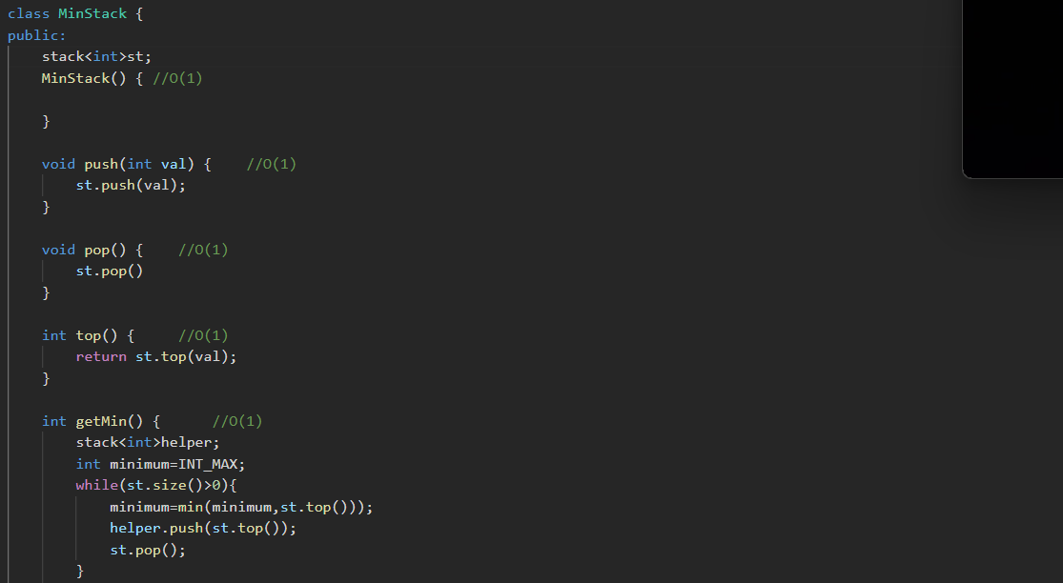 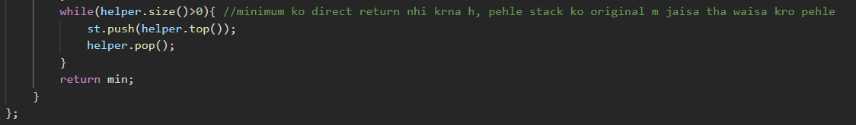

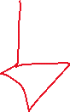

* We have made this function of O(n) time , but we have to make it of O(1) time.

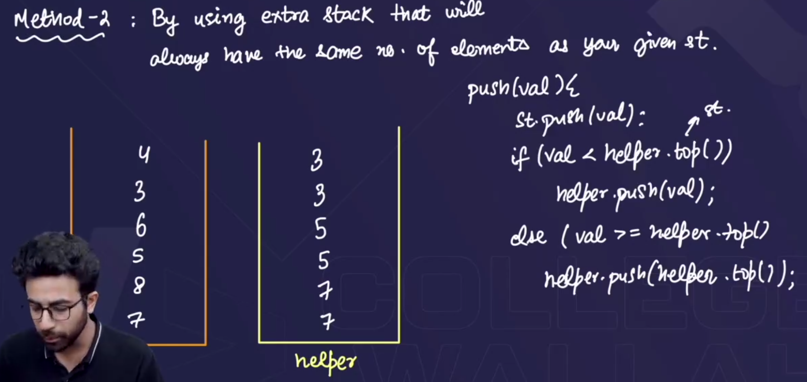



* Suppose elements given are: 7,8,5,6,3,4. We will make two stacks one original stack jisme hm saare elements ko ek ek krke push krte rhenge,

but in the helper stack🡪 agar dono stack is empty then, 1st element dono m push krwa do, but if stacks are not empty then jo value h usko compare kro ki woh chota h ya bada from st.top() , if chota hua then helper waale stack m push krwa do and bada hua then pehle wala value hi push krwa do in the helper stack.

* Now ab hmse koii stack ka minimum value poochega then, helper k top p jo element hoga whi sbse minimum hoga (but dono stacks m same number of elements hona chahiye).

